WEEK 2 DAY 3
TASK 2

CREATE DATASET 1 TABLE
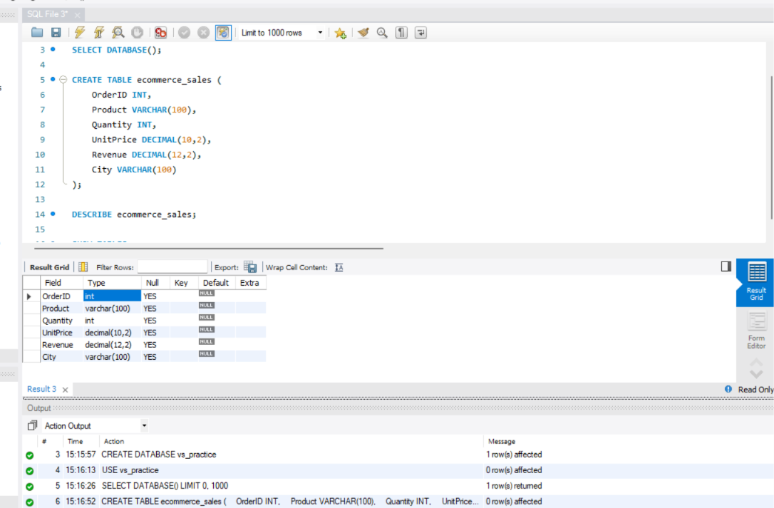
Query 1: Display all records
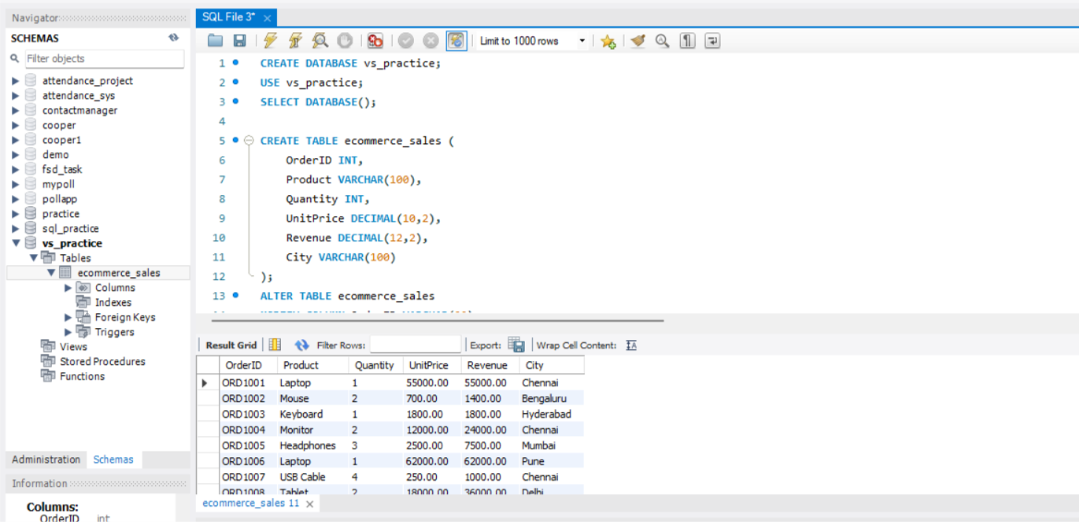

Query 2: Filter products by city
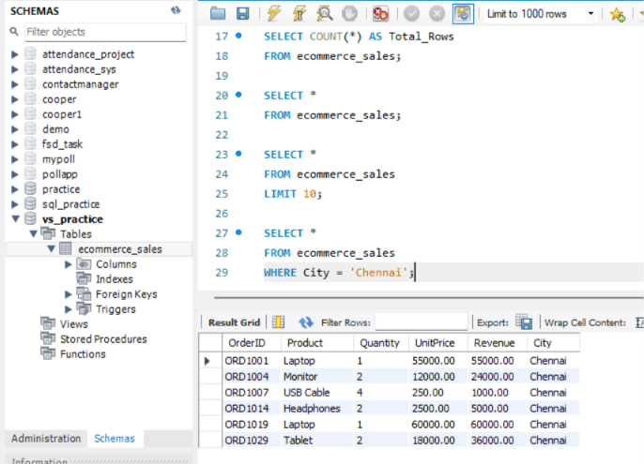
Query 3: Sort orders by revenue
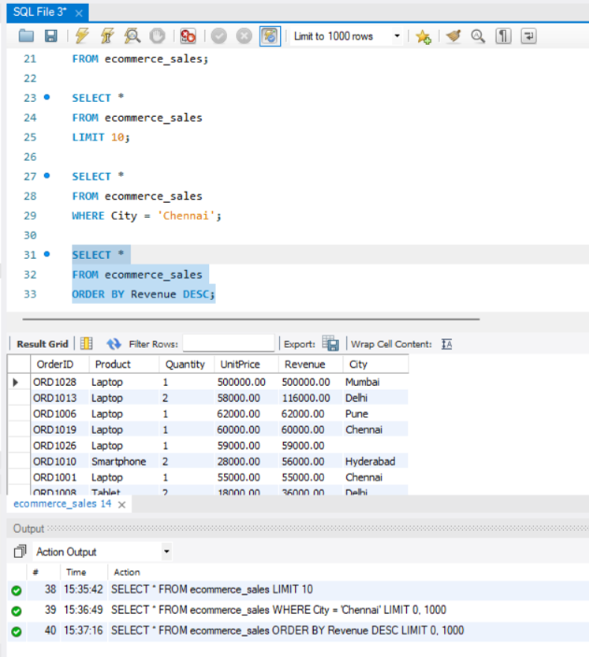

Query 4: Calculate total sales and average revenue
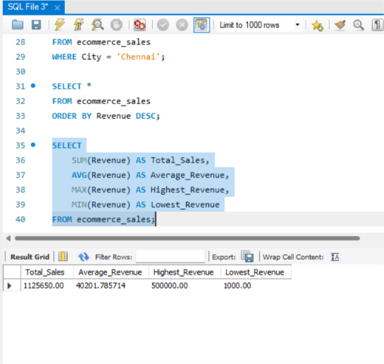
Query 5: Calculate revenue by city
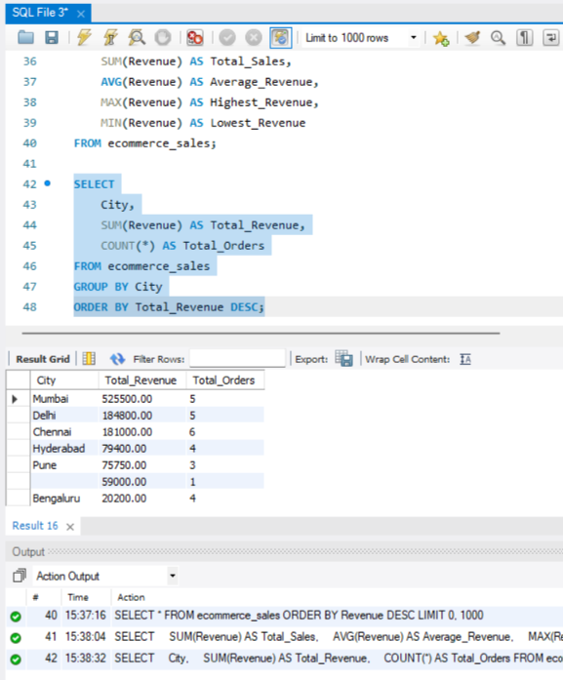

Query 6: Find cities with total revenue above ₹50,000
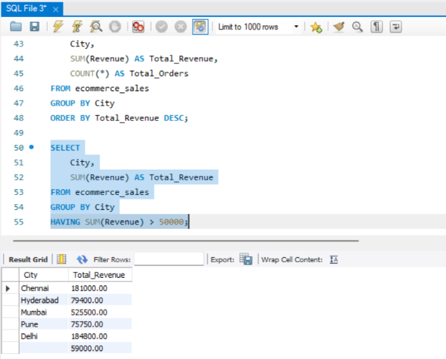
Query 7: Find products with above-average revenue
